# WEEK6

Q1) Objective

Inthischallenge,we'regoingtouseloopstohelpusdosomesimplemath.CheckouttheTutorialtabto learn more.

Task

Givenaninteger,***n***,printitsfirst***10***multiples.Eachmultiple***nXi***(where***1≤i≤10***)shouldbeprintedon a new line in the form: n x i = result.

InputFormat

Asingleinteger,***n***. Constraints

***2 ≤n≤20***

OutputFormat

Print***10***linesofoutput;eachline ***i***(where***1≤i≤10***)containsthe ***result***of***nXi*** intheform: n x i = result.

SampleInput 2

SampleOutput 2 x 1 = 2

2 x2= 4

2 x3= 6

2 x4= 8

2 x5= 10

2 x6= 12

2 x7= 14

2 x8= 16

2 x9= 18

2 x10=20

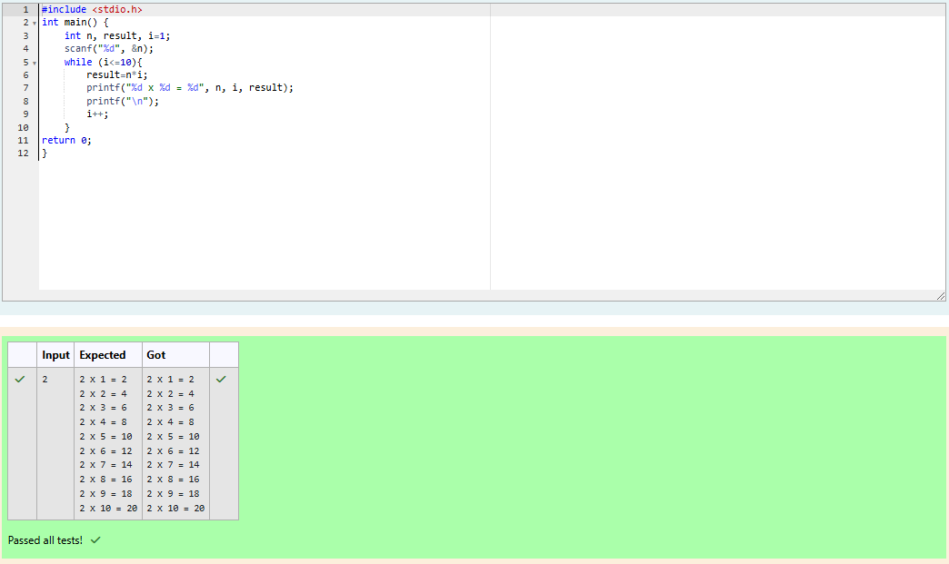

Q2)Anutritionistislabellingallthebestpowerfoodsinthemarket.Everyfooditemarrangedinasingle line, will have a value beginning from 1 and increasing by 1 for each, until all items have a value associatedwiththem.Anitem'svalueisthesameasthenumberofmacronutrients ithas.Forexample, food item with value 1 has 1 macronutrient, food item with value 2 has 2 macronutrients, and

incrementinginthisfashion.

Thenutritionisthastorecommendthebestcombinationtopatients,i.e.maximumtotalof

macronutrients.However,thenutritionistmustavoidprescribingaparticularsumofmacronutrients(an 'unhealthy'number), andthis sumis known.The nutritionist chooses fooditemsinthe increasingorder oftheirvalue.Computethehighesttotalofmacronutrients thatcanbeprescribedto apatient,without the sum matching the given 'unhealthy' number.

Here'sanillustration:

Given *4* food items (hence value: *1,2,3* and *4*), and the unhealthy sum being *6* macronutrients, on choosingitems*1,2,3* ->thesumis*6,*whichmatchesthe'unhealthy'sum.Hence,oneofthethreeneeds to be skipped. Thus, the best combination is from among:

· *2 +3+4 =9*

· *1 +3+4 =8*

· *1 +2+4 =7*

Since*2+3+4=9,* allowsformaximumnumberofmacronutrients,9istherightanswer.

Completethecodeintheeditorbelow.Itmustreturnanintegerthatrepresentsthemaximumtotalof macronutrients, modulo *1000000007 (109 + 7)*

Ithasthe following:

*n:*anintegerthatdenotesthenumberoffooditems

*k:*anintegerthatdenotestheunhealthynumber

# Constraints

· *1 ≤n ≤2× 109*

· *1 ≤k≤4 ×1015*

InputFormatforCustomTesting

Thefirstlinecontainsaninteger,*n*,thatdenotesthenumberoffooditems. Thesecondlinecontainsaninteger,*k*,thatdenotestheunhealthynumber. **Sample Input 0**

2

2

# SampleOutput0

3

# Explanation0

Thefollowingsequenceof*n=2*fooditems:

1. Item1has1 macronutrients.
2. *1+2=3*;observethatthisisthemaxtotal,andhavingavoidedhavingexactly*k=2*macronutrients.

# SampleInput1

2

1

# SampleOutput1

2

# Explanation1

1. Cannotuseitem*1*because*k=1*and*sum≡k*hastobeavoidedatanytime.
2. Hence,maxtotalisachievedby*sum=0+2=2*.

SampleCase2

# SampleInputforCustomTesting Sample Input 2

3

3

# SampleOutput2

5

# Explanation2

*2+3=5,i*sthebestcaseformaximumnutrients.

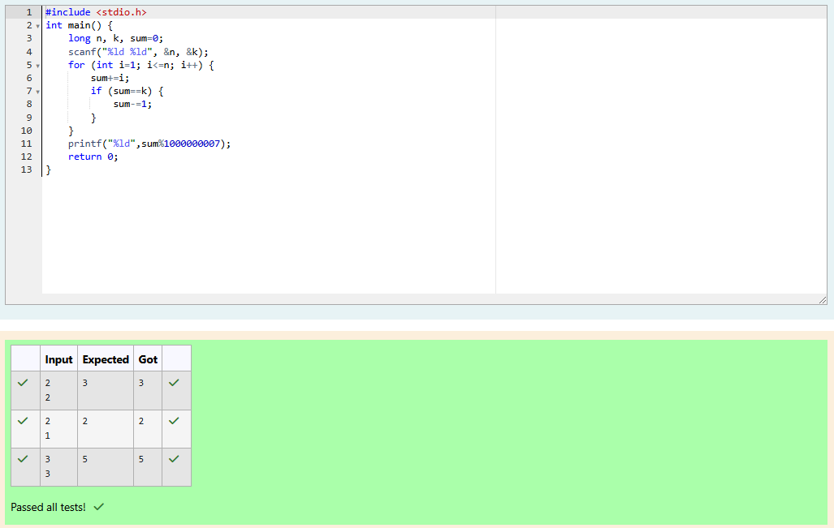

Q3)Determineallpositiveintegervaluesthatevenlydivideintoanumber,itsfactors.Return the *pth*element of your list, sorted ascending. If there is no *pth*element, return *0*.

Forexample,giventhenumber*n=20*,itsfactorsare*{1,2,4,5,10,20}*.Using**1-basedindexing**if*p=3*, return *4*. If *p > 6*, return *0*.

Completethecodeintheeditorbelow.Thefunctionshouldreturnalongintegervalueofthe *pth*integer factor of *n*.

Ithasthe following:

*n:*aninteger

*p:*aninteger

# Constraints

· *1≤n ≤1015*

· *1 ≤p ≤109*

InputFormatforCustomTesting

Inputfromstdinwillbeprocessedasfollowsandpassedtothefunction. The first line contains an integer *n*, the number to factor.

Thesecondlinecontainsaninteger*p*,the1-basedindexofthefactortoreturn.

# SampleInput0

10

3

# SampleOutput0

5

# Explanation0

Factoring*n=10*weget*{1,2,5,10}*.Wethenreturnthe*p=3rd*factorasouranswer.

# SampleInput1

10

5

# SampleOutput1

0

# Explanation1

Factoring*n=10*weget*{1,2,5,10}*.Thereareonly*4*factorsand*p=5*.Wereturn*0*asour answer.

# SampleInput2

1

1

# SampleOutput2

1

# Explanation2

Factoring*n=1*weget*{1}*.Wethenreturnthe*p=1st*factorasouranswer.

